Notes App installation instructions:

To run the notes app on your own hardware, you will need to perform a few necessary steps. First will be steps in order to run the applications in production mode, and second will be the steps to run them in development mode.

To get started, you will need a MySQL database installation. To get this, you can go to <https://www.mysql.com/downloads/> and download the installer.

**(If you are installing this onto certain hardware, such as a Raspberry Pi or other headless Linux options, these installation options will be different. Do a Google search for “how to install MySQL on X” to get your specific device options)

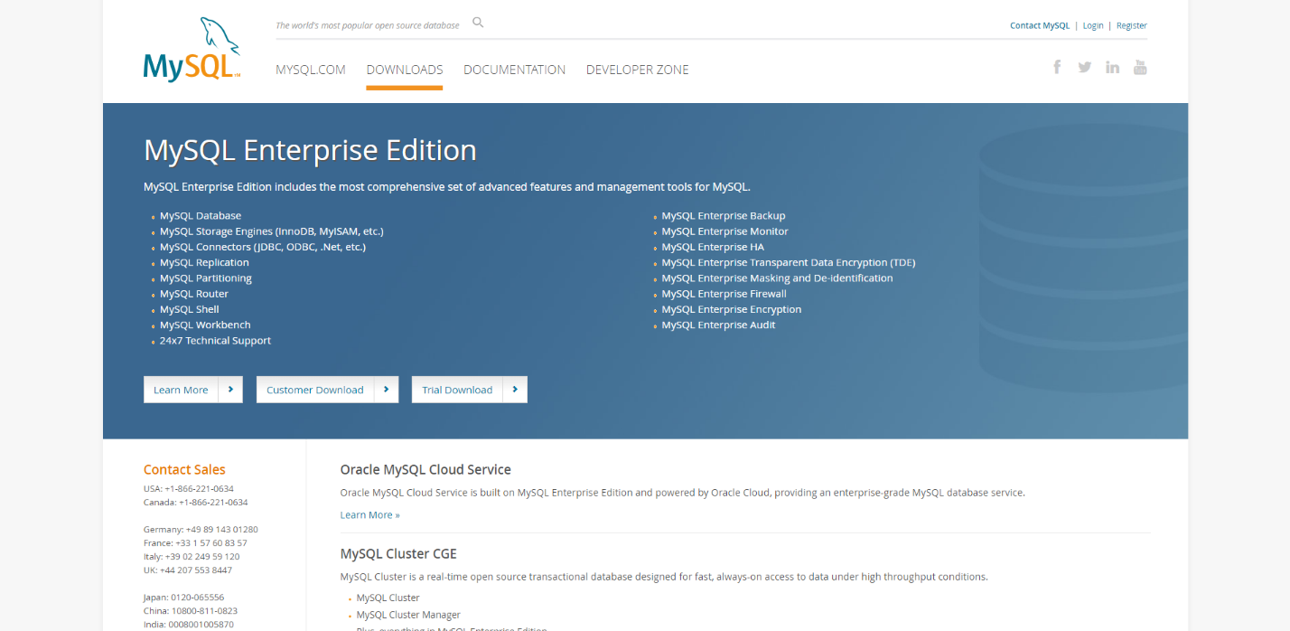

You’ll most likely want to scroll down to the bottom and select the community edition options.

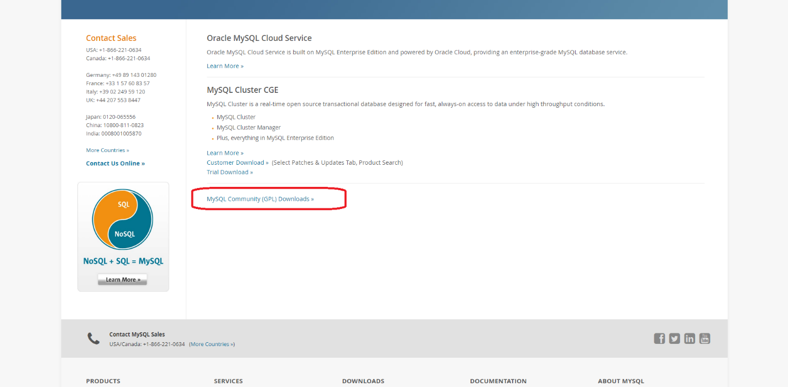

You’ll want to either download the server and the Workbench (GUI) options, or just download the installer which will allow you to choose your options later.

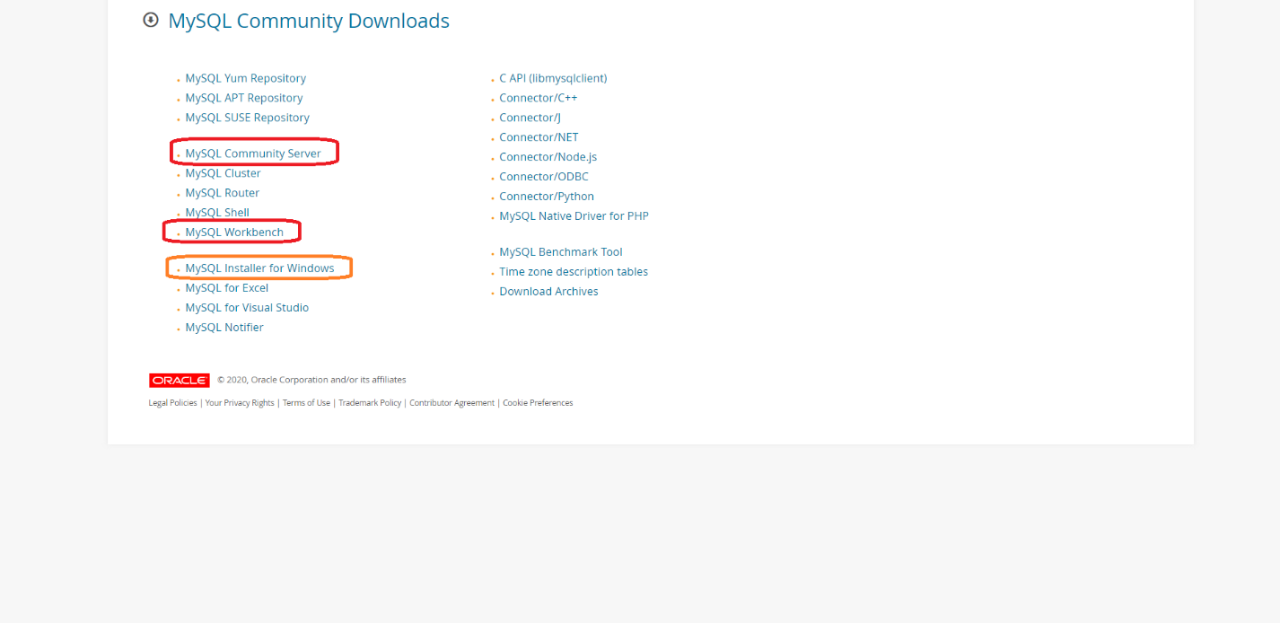

You can choose your Operating System and whether you want 32 or 64 bit where applicable.

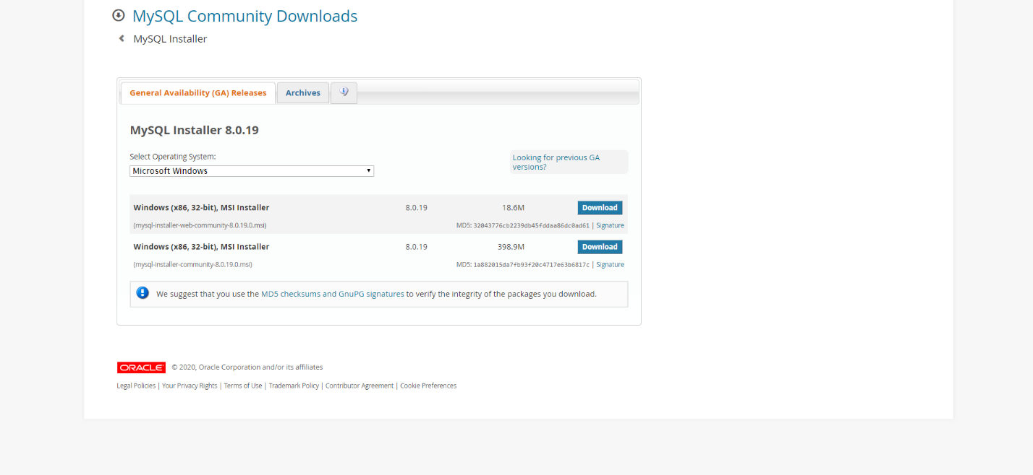

If you don’t have an Oracle account, you can skip it by clicking “no thanks”

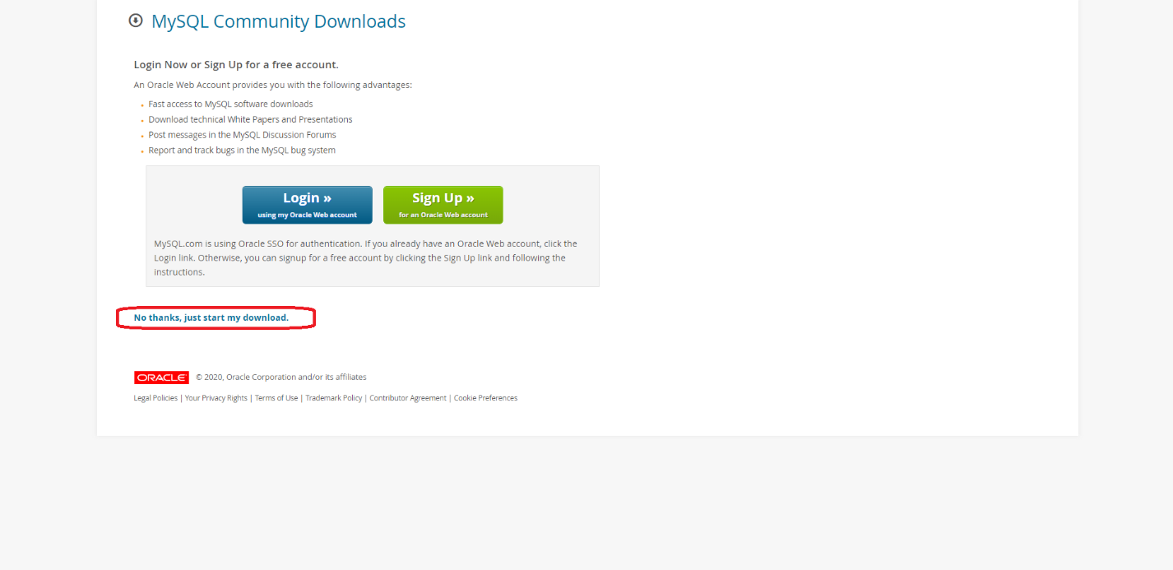

Once you have the installer downloaded and ran, you can choose your installation options and review any you may already have:

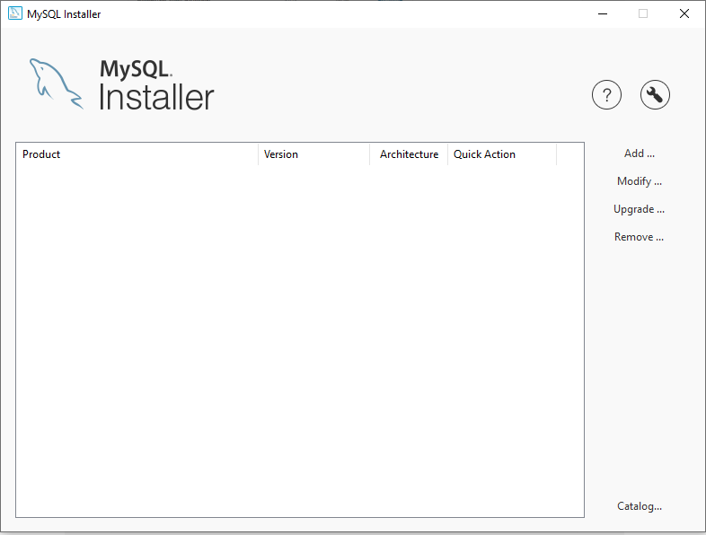

You will want to add the server at minimum, but the Workbench option will make interacting with the database much easier so I highly recommend that as well.

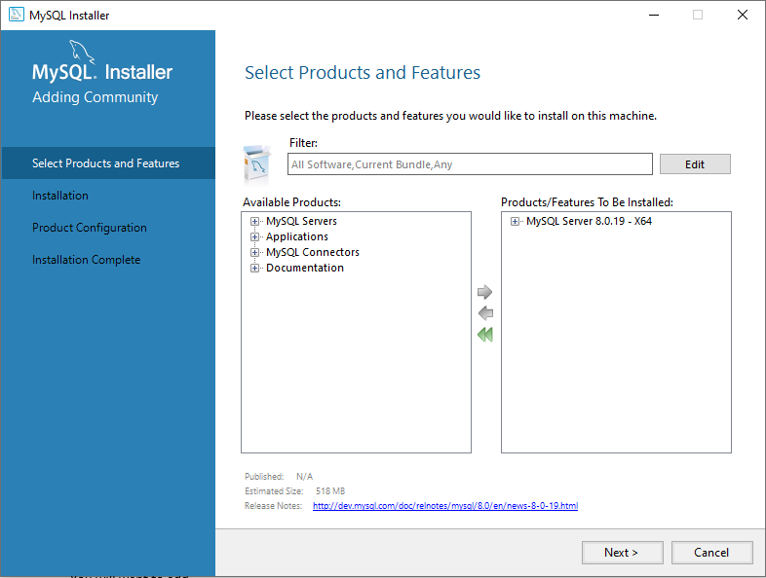

If you’ve chosen to work with the command line version of MySQL you probably can skip ahead and do that now, but if you’ve chosen the Workbench option, you will want to add a new connection.

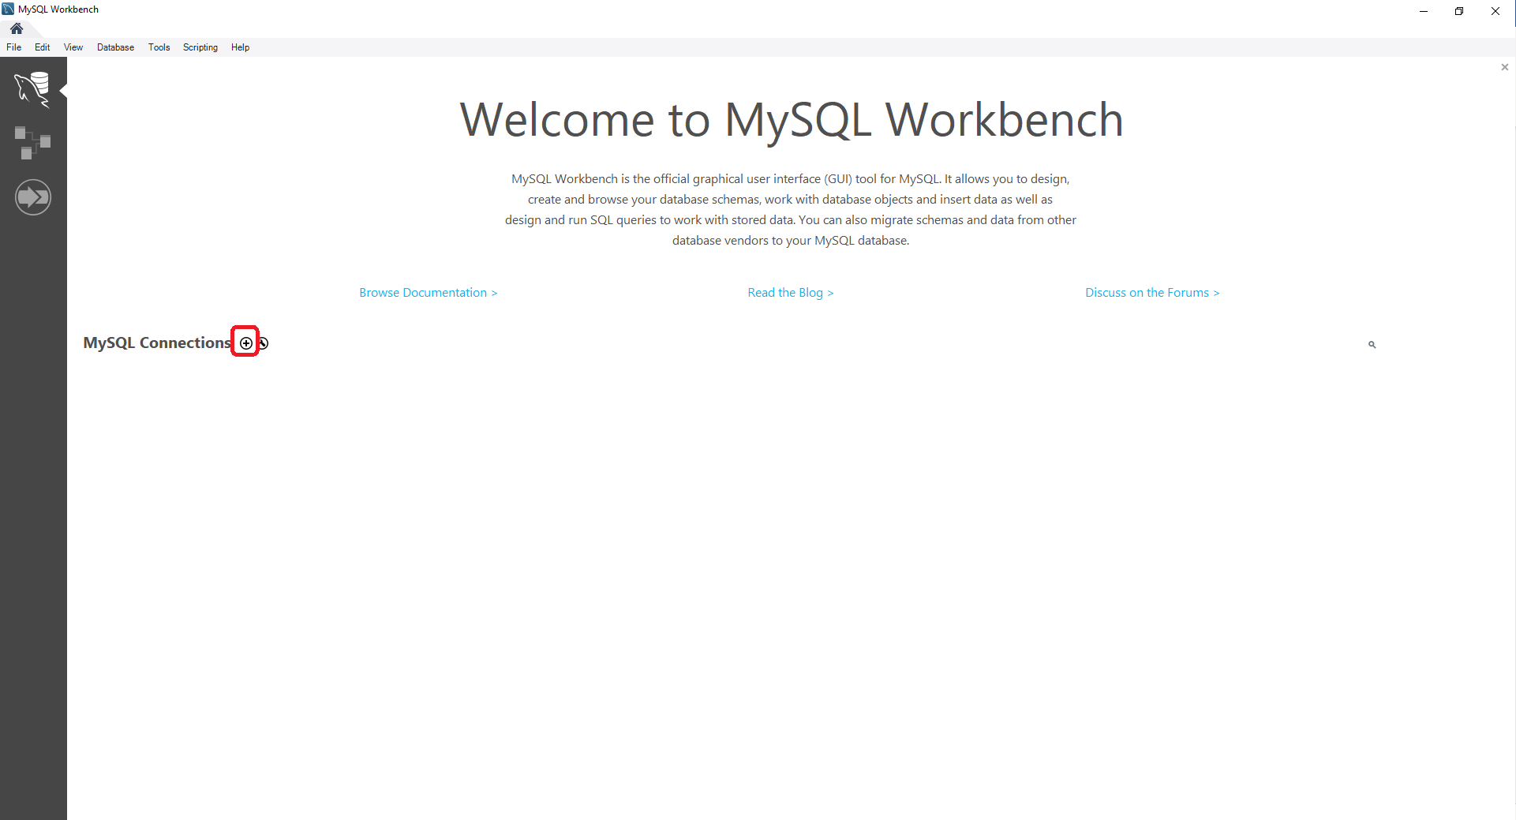

Go ahead and enter your connection information and feel free to log in as well.

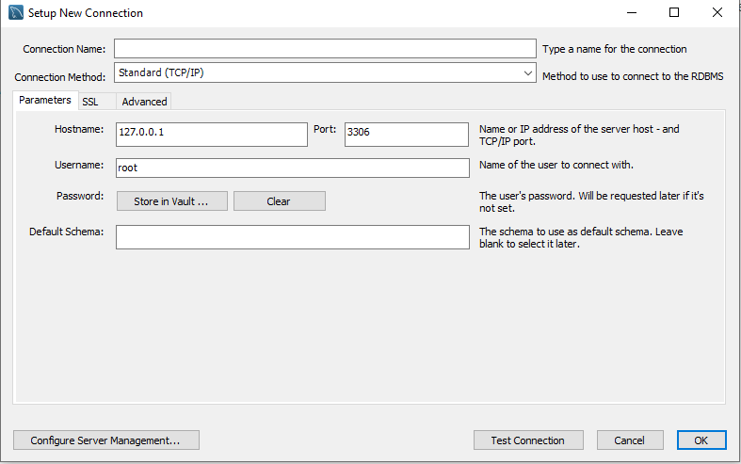

Go ahead and load the SQL provided to install the schema and tables to your database

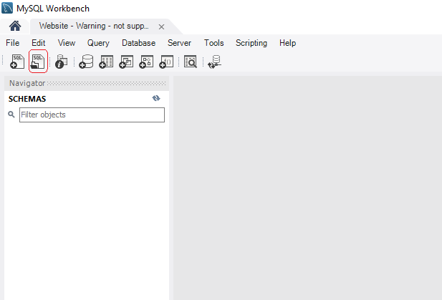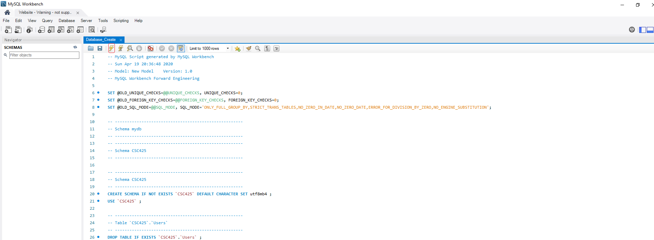

You will then have the Database available and can explore the layout of it.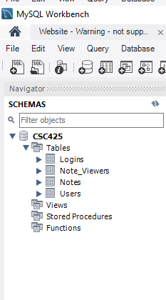

You will then need to install a webserver software such as Apache or IIS. With the infinite possibilities, I can’t possibly cover all of them here, but make your choice and install that option onto your device, and then download the frontend code package either from <https://github.com/Rohzek/CSC425/releases/tag/1.0.0_FE> or from the project files, and compile it yourself.

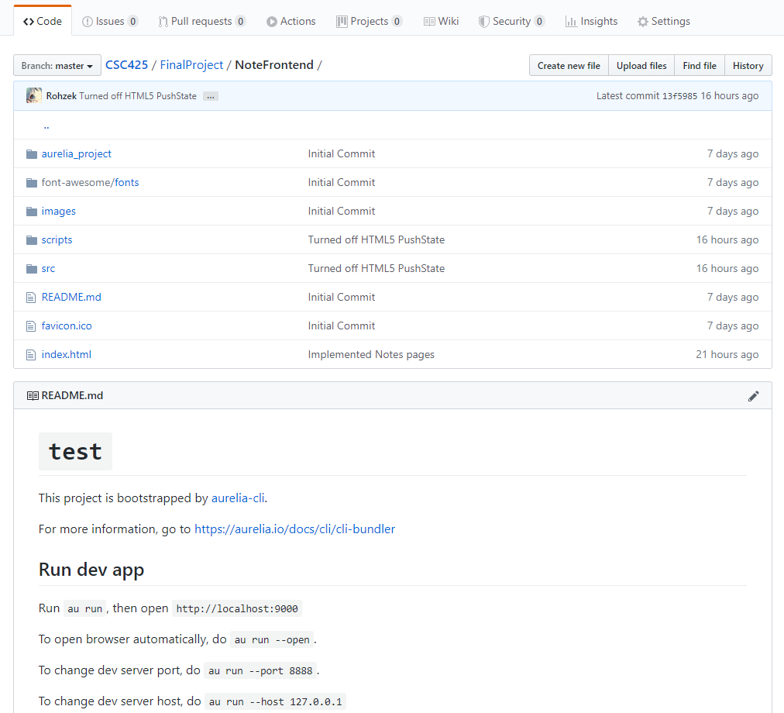

For deploying onto the webserver, you only need font-awesome, images, scripts, favicon.ico, and index.html to be included in your webserver root directory.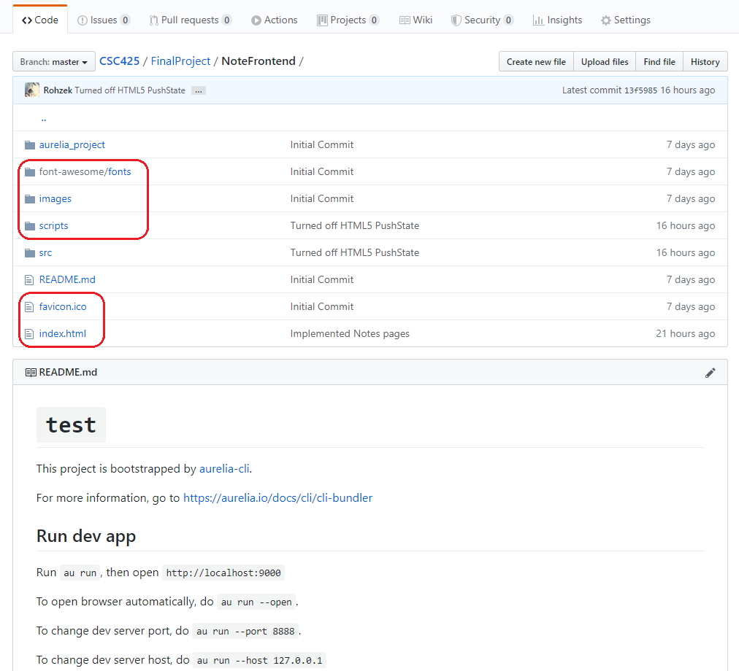

You will then have the frontend live when you type the address into your browser.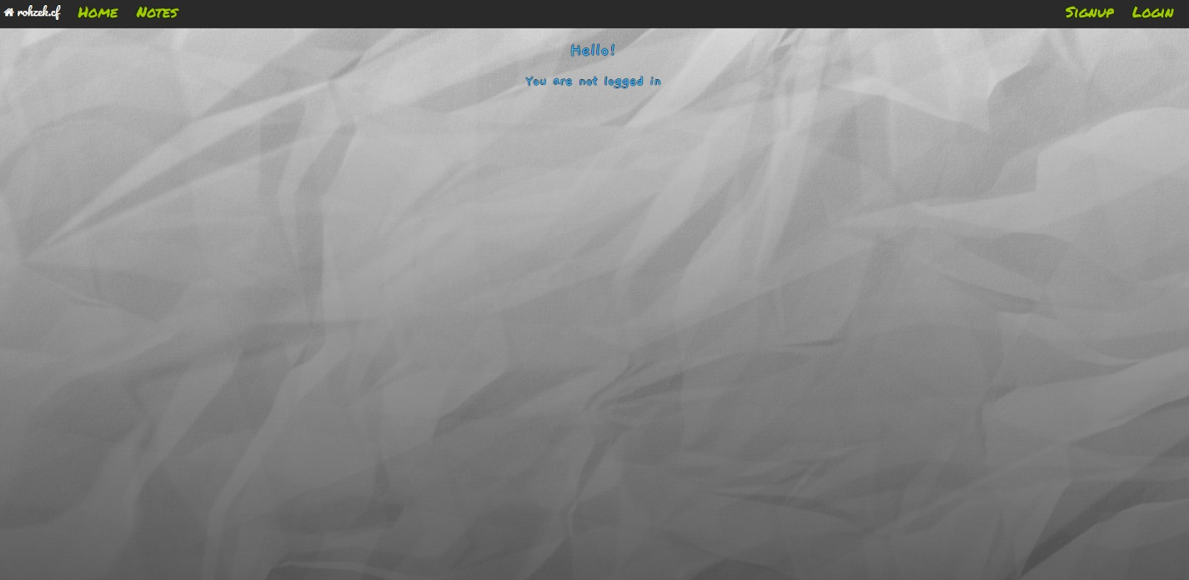

To enable any of the functionality however, you will also need the API running, and will need to change the URL for the API in the code of the server.

To get the API running, either download the release from <https://github.com/Rohzek/CSC425/releases/tag/1.0.0_BE> or use Visual Studio to compile the project for your own device.

You will need to change the connection settings to fit your own settings:

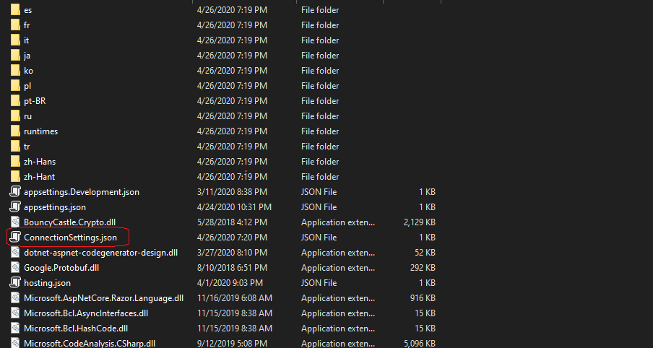

The options are as follows:

IP is the IP (or URL) to connect to the MySQL database. Port is the port it’s running on, User and Password is the credentials for logging into the database. Database is the schema name to connect to.

Account is a Gmail email address that’s enabled to allow applications to send emails, Name is the name to be displayed as the sender on the email. Creds is the password to log into the email account.

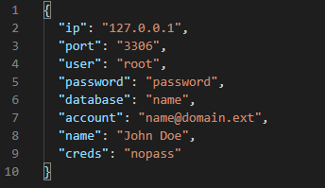

To enable application emails for your Gmail account, go to your account settings on any Google website:

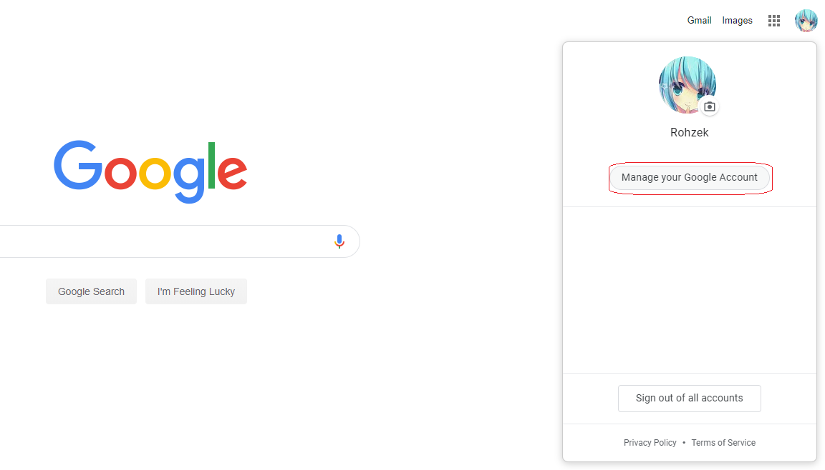

You will need to generate an App password:

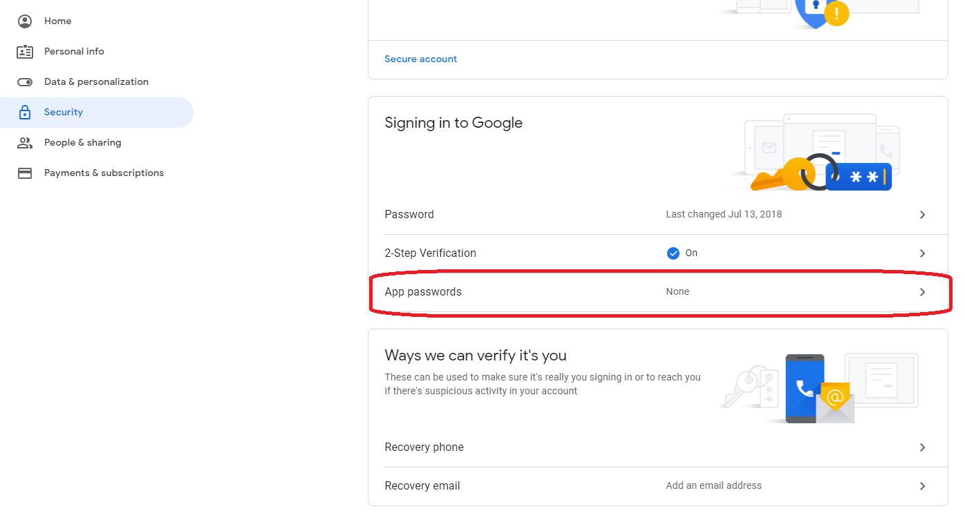

And enable “less secure apps”

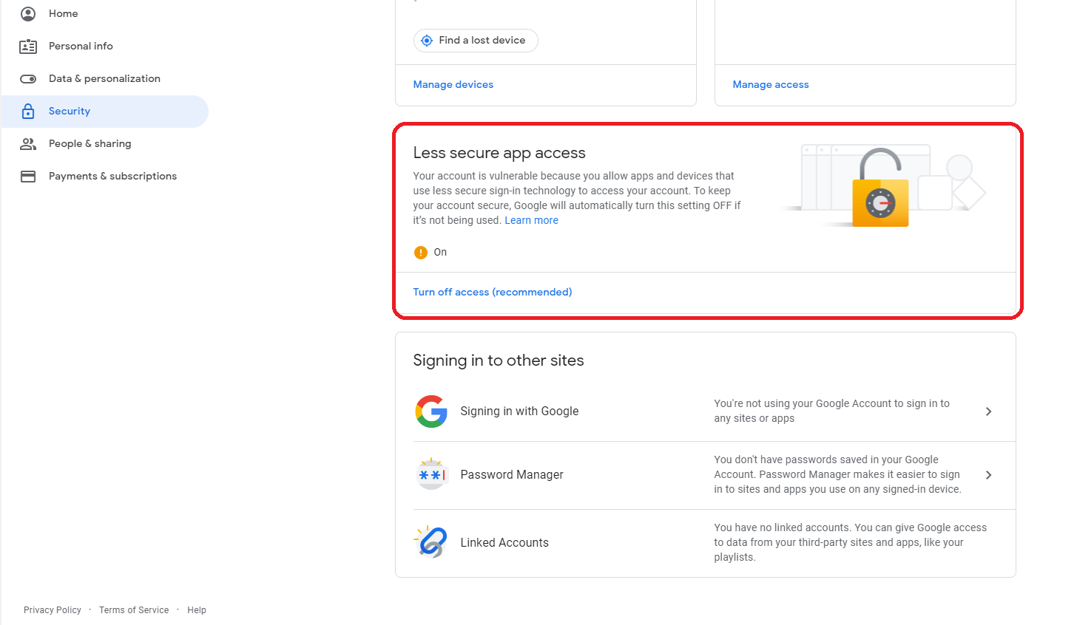

You can then run the API through either the dll file, or the exe file.

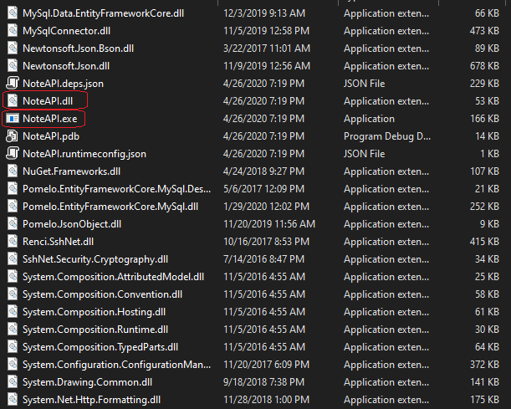

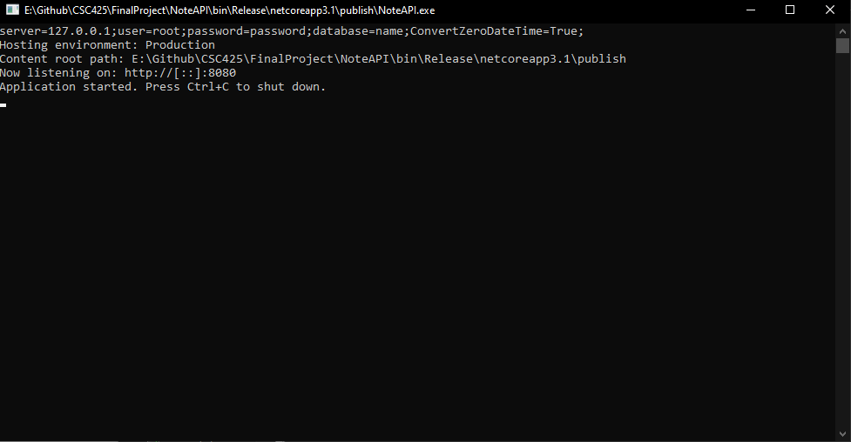

To enable the front end to connect to your API, you must change the connection strings in the code. To do this the easy way, simply open three JS files in the scripts folder:

app-bundle-296ad61afd.js, app-bundle-68a4df0388.js, app-bundle.js

Control-F the current connection string (<http://rohzek.cf:8080>) and change it to your own link. These will be following the code: .withBaseURLs(). If you are connecting locally on your device, it’ll be <http://localhost:8080>, but if you’re hosting it on another device than the front end is running on, it will be different. Make sure to leave the ending as /api/v1/ or the API won’t be reached. 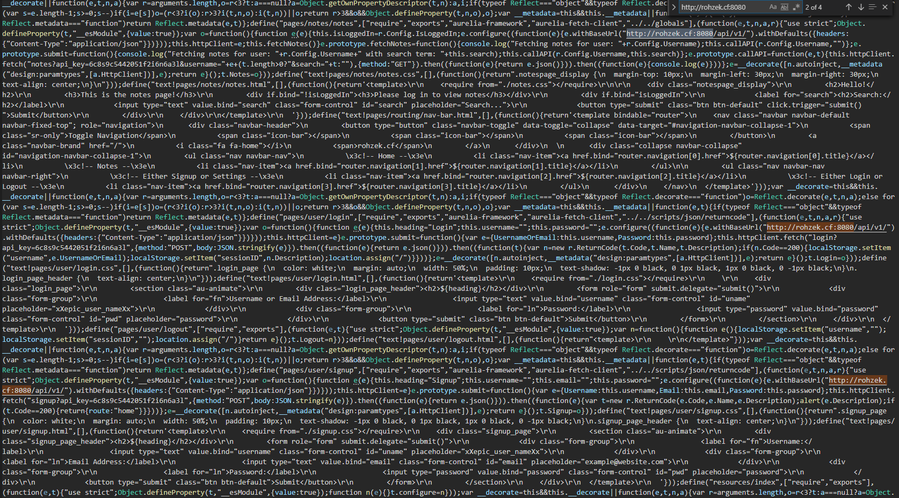

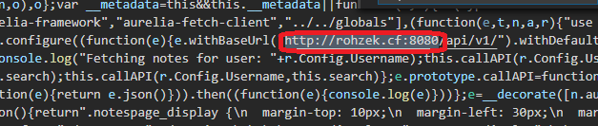

You now have the app up and running on your own hardware.

To make fundamental changes, you will need to open the software in the developer tools.

To edit the front end, any text editor will suffice, but I highly recommend using Visual Studio Code for the ease of use, abundance of plugins to add any feature you like, and excellent syntax highlighting.

You can download it for your Operating System of choice from <https://code.visualstudio.com/>

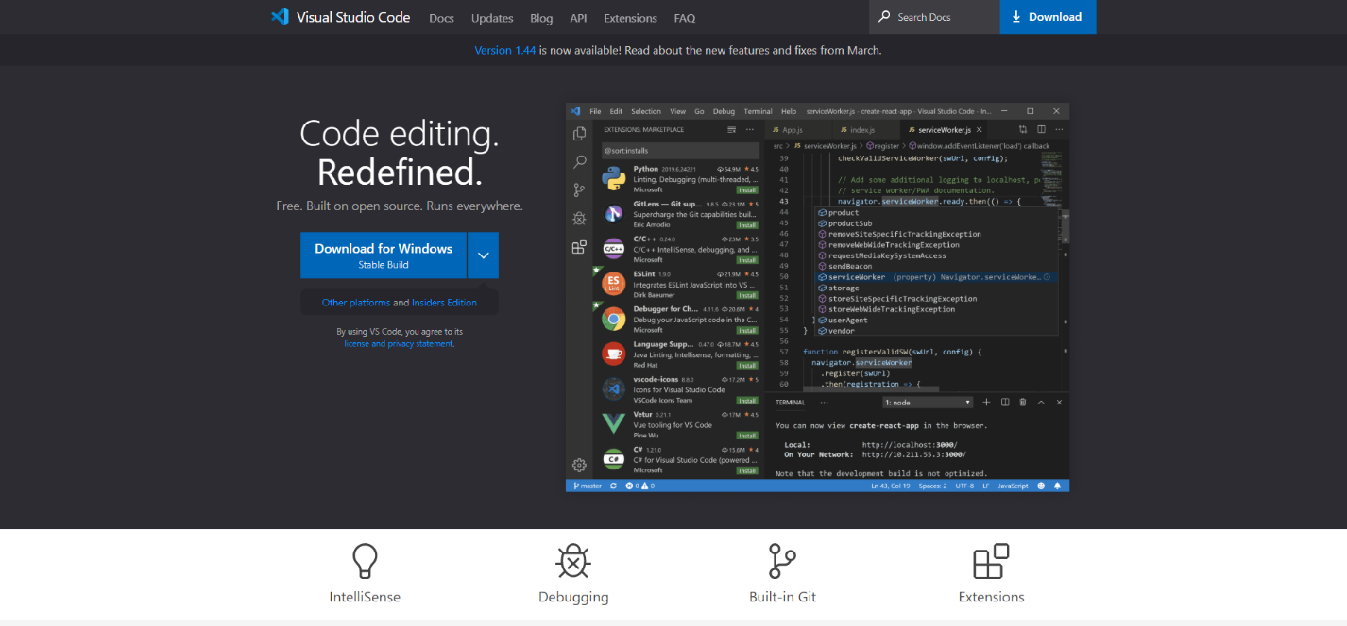

Once installed, you can open the folder containing the front end code, and see it in the browser.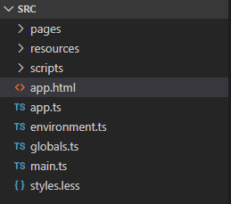

It’s very easy to run through, open several files into tabs and make changes.

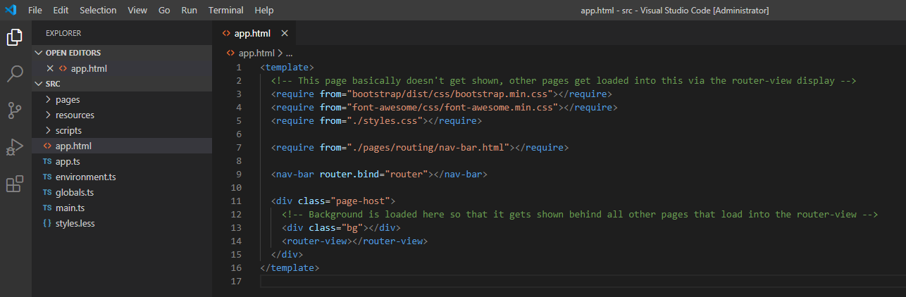

To run the application, and/or to compile your changes, you will need NodeJS. NodeJS can be downloaded from <https://nodejs.org/en/> for your choice of Operating System

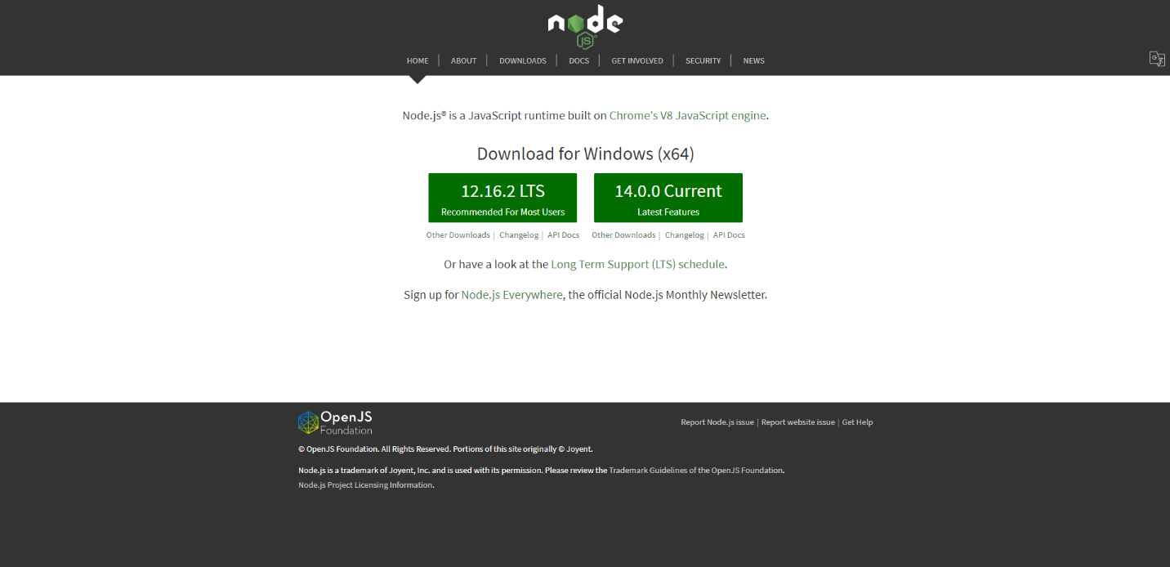

Once NodeJS is installed, open Windows PowerShell and CD into the folder containing the project.

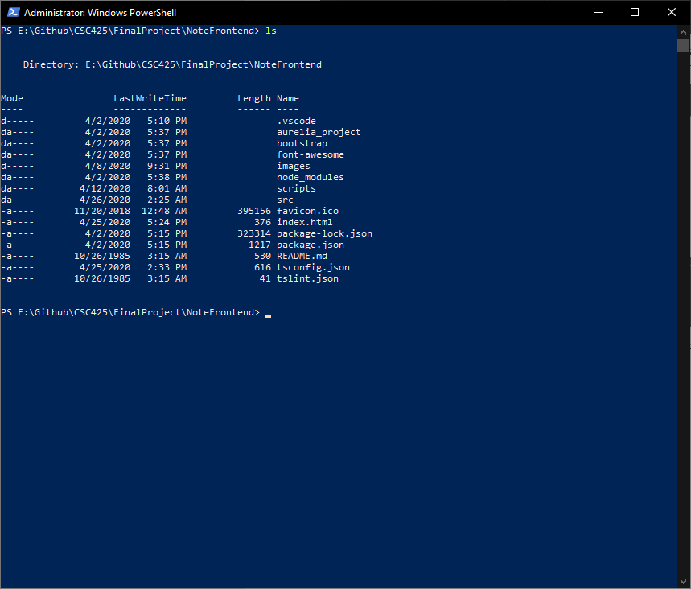

You will need to run npm install to install the dependencies into the node_modules folder in the project directory

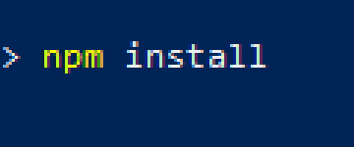

Once that’s done, you will also need to install the Aurelia Framework globally in order to load the project and run it. 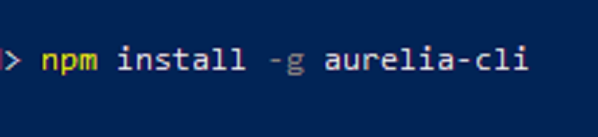

Once all the dependencies have been installed, you can run the project with the command au run

With the optional flag –watch to enable automatic refreshing.

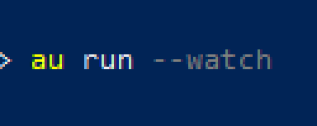

The project is now running locally in dev mode, and you can go to <http://localhost:9000> to view it in your browser.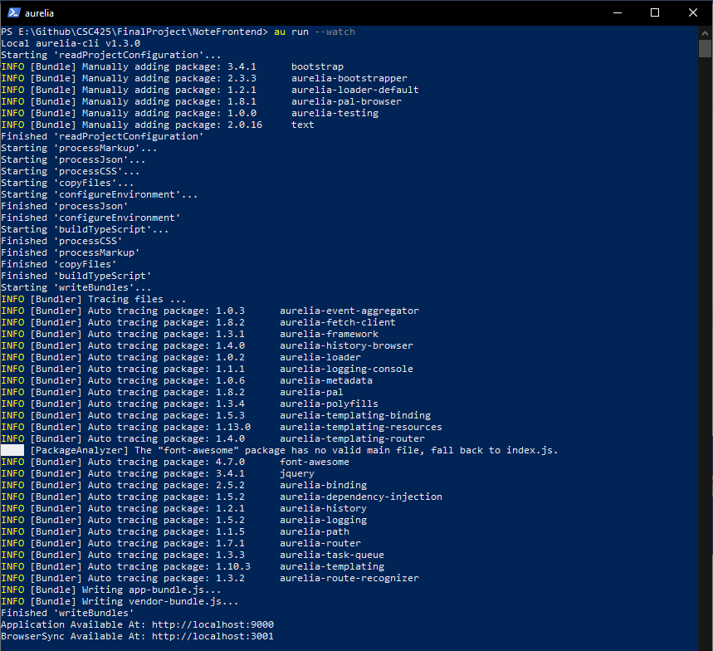

When you’re finished making changes, you can build the project with the command au build –env-prod

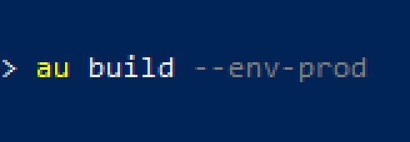

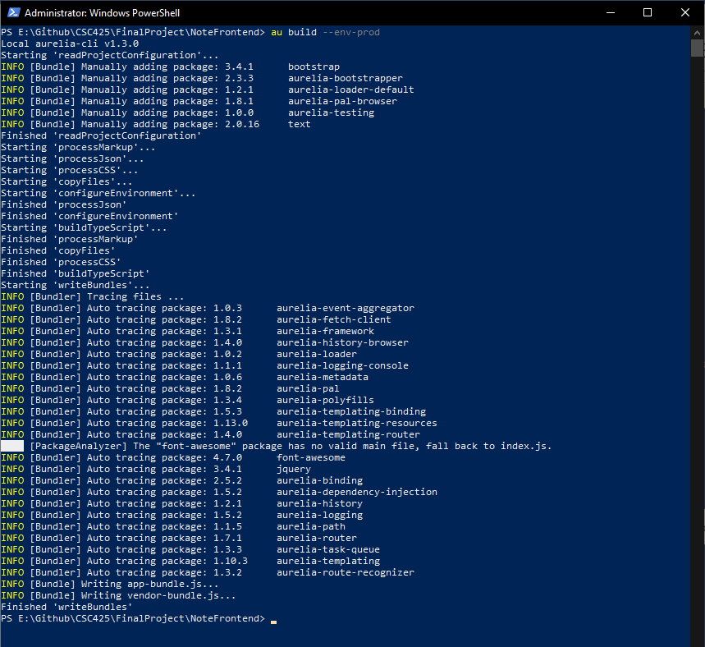

After the project is built, you can copy the same 5 files (font-awesome, images, scripts, favicon.ico, and index.html) into your webserver, overwriting the old ones and clear the cache on your browser, and your new site will be live.

To edit the backend, you need Visual Studio which can be downloaded from <https://visualstudio.microsoft.com/> If you choose the Community edition, it’s free – requiring only a free Microsoft account to use.

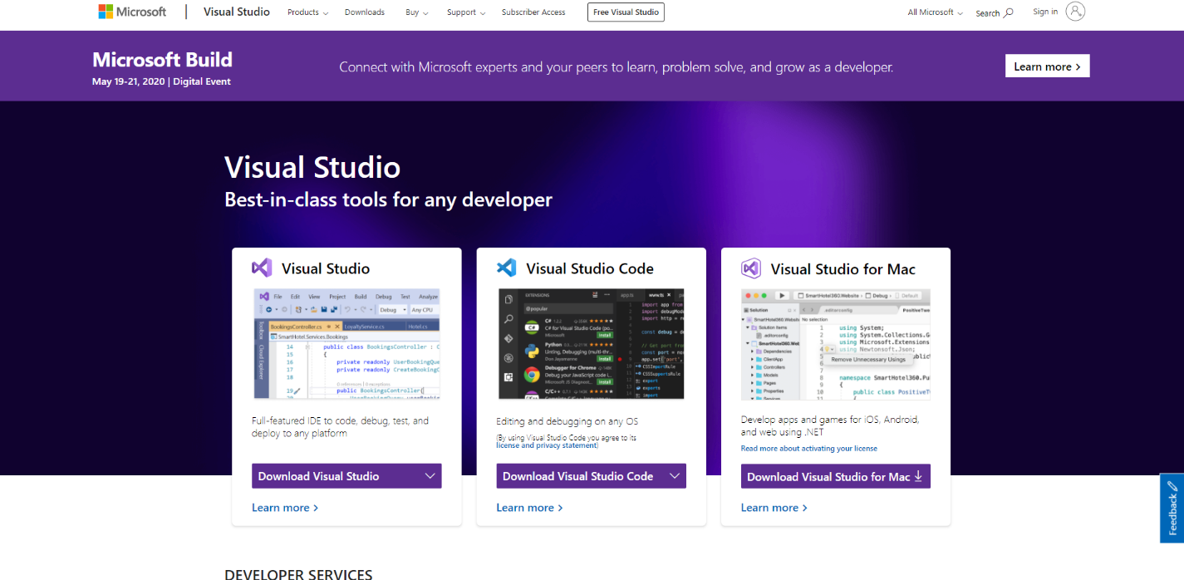

Once installed, you can open the project files which were downloaded from GitHub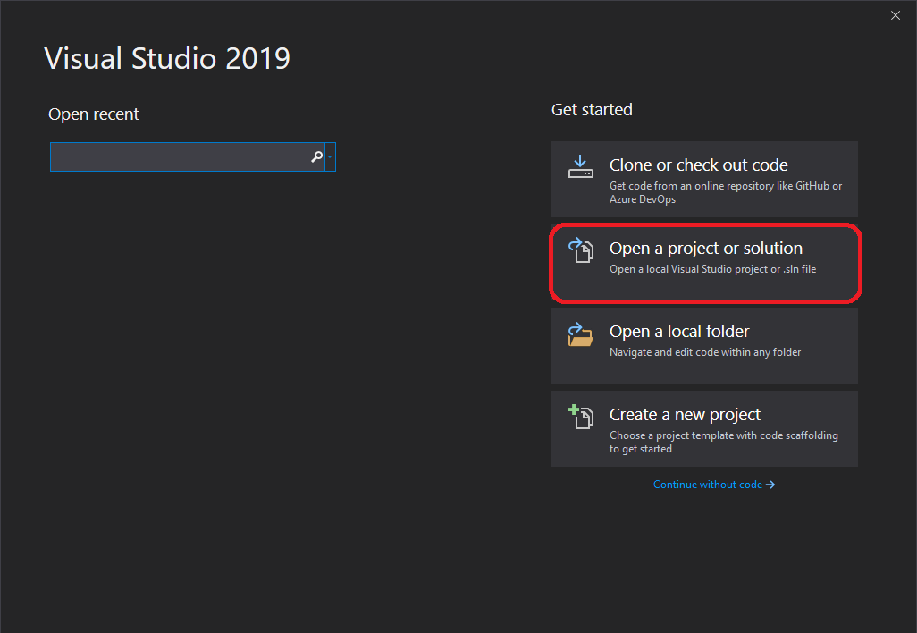

Once the project is open, you will need to first download all of the missing dependencies by right clicking on the solution, and selecting restore packages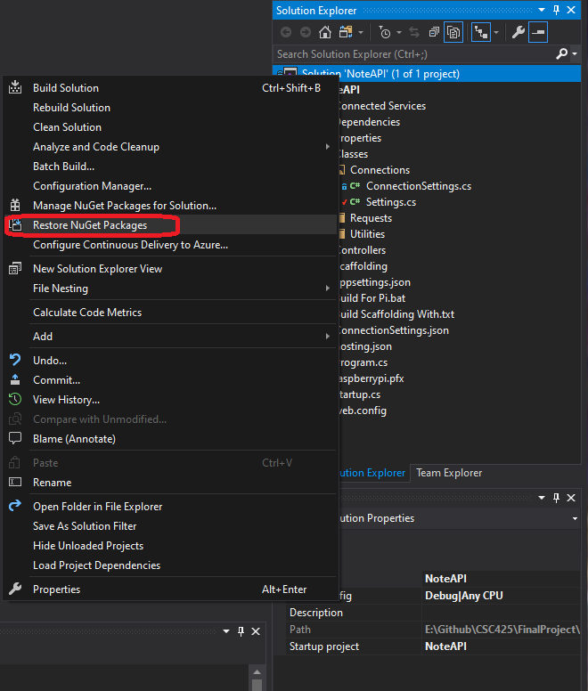

You’re then free to edit the code as you see fit, and test by selecting Run settings and clicking Run.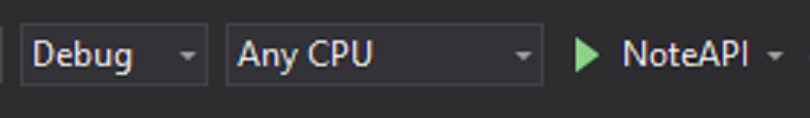

When you are finished with your changes and are ready to deploy the new API to your device, select Publish

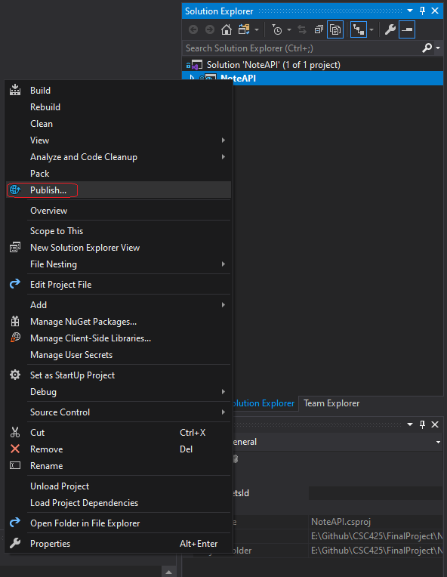

Changes to the database can be made easily the same way as before, using MySQL Workbench.

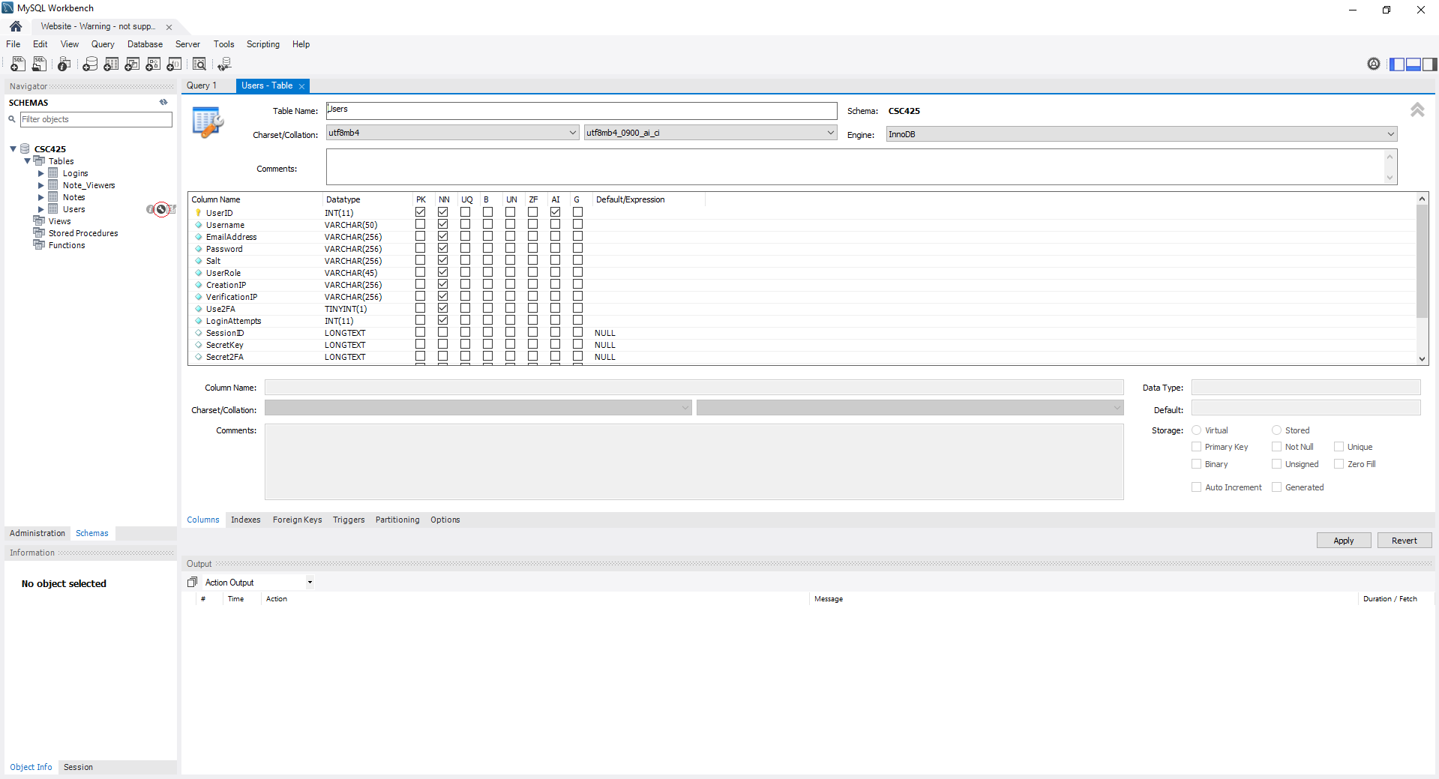

You’re now ready to run and configure the apps as you see fit.